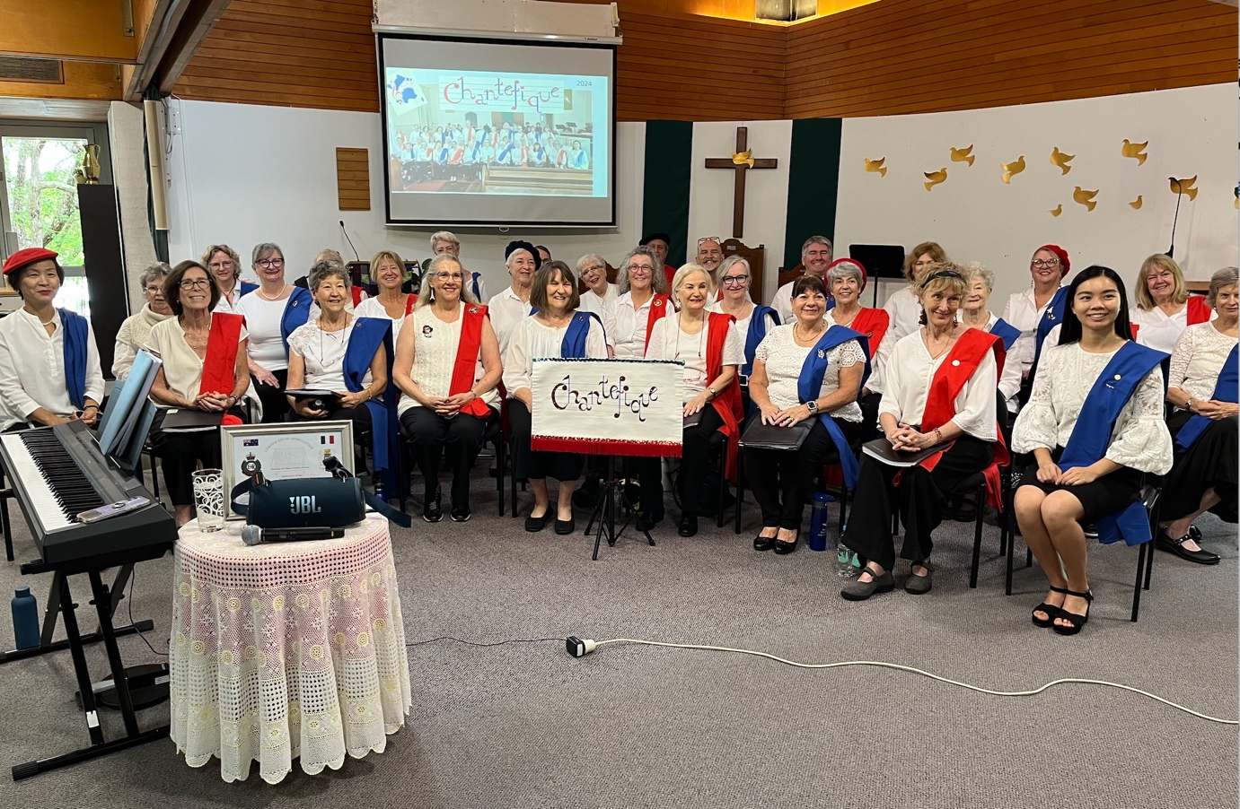

Bonjour! Join us for the last Music Lovers for 2025 on Thursday 20th October, at Kenmore Uniting Church, when we will be welcoming Chantefique, Brisbane's only French-singing choir. They are a friendly group, united by their love of music and their affection for French culture. They sing at various events such as the French Film Festival, Bastille Day celebrations, the Beaujolais Nouveau and of course Christmas festivities. Their current repertoire embraces a diverse range of French classical ballads through to modern favourites. They rehearse 4pm Friday afternoons at St Francis of Assisi Hall, West End and would love you to join them. Contact Narelle 0402075269 for more information.

We are looking forward to a splendid morning, so please join us.
Kenmore Uniting Church, 982 Moggill Road, Kenmore.
10 am to 11.30 with a short interval for light Morning Tea. Entry at the door $10, includes morning tea.
Enquiries to the Church Office on 3378 4505 or kenmoreuc01@gmail.com

